**Statement of Work for The Energy Storage Rights**

**Produce for Computing Project @ANU**

Abstract

This is an ongoing project for Energy Storage Rights. It aims to create a Web platform that allows users to see the return of investment on potential sites generated by renewable energy technologies. The target users include small enterprises, organizations, individuals. Technologies used include Data Mining, Machine Learning, and Web development. In summary, an applicable and portable website app which can evaluate and utilize the renewable energy output for potential users is our client’s desired outcome at the end of the project.

# Authorization

Author:

Approved By

Name ............................................................

# Document history

|  |  |  |  |  |
| --- | --- | --- | --- | --- |
| **Version** | **Date** | **Changed sections** | **Revise by** | **Signature** |
| 1.0 | 14/03/2019 |  | Tudor |  |
| 1.1 | 25/03/2019 | * Objectives * Our data sources (New) * Algorithm Design (Del) * Computation Design (New) * Deliverables * Milestones (Del) * Change Management(Del) |  |  |
| 2.0 | 01/08/2019 | * Change third Deliverables add 2 stages under third deliverables. |  |  |
|  |  |  |  |  |
|  |  |  |  |  |
|  |  |  |  |  |
|  |  |  |  |  |
|  |  |  |  |  |
|  |  |  |  |  |
|  |  |  |  |  |
|  |  |  |  |  |
|  |  |  |  |  |
|  |  |  |  |  |
|  |  |  |  |  |

## Deliverables

### First deliverable:

* A basic website with maps ready to use

1. A basic map with some basic functions including search, zoom in & out.
2. A user interface which should be able to display renewable energy distribution in map.

* Basic data is sourced

Relevant data of World-wide Wind speed, Solar exposure, Water coverage

* Basic data is normalized and ready to use

The data we search should be modified to the same format which can be used and visualized by our map.

* Being able to visualize layer data

A kind of renewable energy will be shown on our map, including solar, wind and hydro energy, which will be displayed on different layers, at least for sample size scale.

### Second deliverable (MVP)

* Other relevant data is sourced

1. Solar energy: cloud amount and sunrise time, sunset time
2. Wind energy: wind direction, wind gust
3. Water energy: The depth of lake, precipitation

* Energy grid data is implemented

Display energy grid on map and their distances between each other.

* Calculate the user selected area

The selected area can be in polygon or rectangle. Once our user select the area they want to learn about, our application should be able to output the estimated electricity generation and its return for each renewable energy annually.

* Calculate the potential return of development

Calculate the estimated gross return of energy storage installation.

* User-friendly interface to display essential information

### Third deliverable

**Contents**

Authorization 2

Document history 3

Background and Introduction 6

Vision and objectives 6

Background 6

Brief Introduction 7

Methodologies 7

Web Development 7

Data Mining 7

Data Visualization 8

Machine Learning 8

Work allocation 9

Objectives and benefits 10

Objectives 10

Desired features 10

Two primary functions 10

A user-friendly interface 11

Smart choices by system 11

How it benefits the client 11

Key stakeholders 13

Client and other stakeholder expectations 13

Make things better for the client and other stakeholders 14

Technical constraint and risk 15

Data reliability 15

Data compatibility 15

Lack of expertise 15

Data coverage 16

Project description and scope 17

Project Design 17

Data sourcing 19

Our data sources 20

Data normalization 20

Data Storage 20

Development kit and relations 20

Computation Design 20

Phase1 20

Phase2 20

Phase3 21

Project timeline 22

Schedule & Milestones 22

Deliverables 22

First deliverable: 22

Second deliverable 22

Third deliverable 22

Project management 23

Change management 23

Task Tracking 23

Decision making process 23

Inspection, test, integration, and acceptance 25

Reference 26

Appendix A- Project schedule 27

Appendix B- Decision-making Log Form 28

Decision-making Log Form 28

# Background and Introduction

This project is acquired from Tudor Barbulescu (tudor.barbu7@gmail.com) and carried out under computing project courses including COMP3500, COMP4500, and COMP8715 from The Australian National University. This project team is led by project manager Yuanxin Ye (u5669371@anu.edu.au) and consist six other team members, Yunyuan Yu (u6092441@anu.edu.au), Yuanxin Ye (u5669371@anu.edu.au), Weiwei Liang (u6642464@anu.edu.au), Yufei Qian (u5981067@anu.edu.au), Peilin Song (u6225953@anu.edu.au), Dawei Zhang (u6302602@anu.edu.au), and Daoyu Li (u5912264@anu.edu.au).

## Vision and objectives

Our client, the team of Energy Storage Rights, wishes to develop an energy evaluation service that can find the best location to get the richest energy source in order to maximize the profit margin for our users, e.g. the real estate. The target users include small enterprises, organizations, individuals. In summary, an applicable and portable website app which can evaluate and utilize the renewable energy for potential users is our client’s desired outcome at the end of the project.

## Background

There is an ongoing trend of renewable energy technologies to be further developed in Australia. However, a platform which allows interaction between the technology developers and the potential user is absent. In 2017, coal still contributes 62% to Australian electricity generation. Thus, the potential of our application is brimming with opportunity.

## Brief Introduction

Deployment of renewable energy technologies in a different location often comes with advantage and disadvantage. The energy storage rights is a digital platform that will map, evaluate, promote and help investments in the development rights for energy storage pilot projects such as pumped hydro energy storage, floating solar pilots on lake or sea. Alongside with the platform is the energy storage rights app.

We strive to build up an application which used to evaluate and optimize the performance and potential of location viable for development of different renewable-energy technologies, this outcome will then be visualized to the target user.

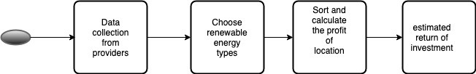

The implementation of the application requires 4 aspects:

1. Data collection from providers

Data collection of renewable energy by its type (solar, wind, water) from providers.

1. Choose renewable energy types

User of the application can choose renewable energy type and visualize the energy distribution.

1. Sort and calculate the profit of location

Sort and calculate the profit by energy type of choosing location

1. estimated return of investment

With user details of investment, the application calculate and get the margin of investment.

## Methodologies

In this project, we will be primarily using the following methodologies:

### Web Development

The client is familiar with Reactjs and is highly recommend us to Reactjs, by acceptance of using Reactjs, this allows the client to be more aware and allow us to create a product that is more aligned with the client requirement. Web development with Reactjs to build up a dynamic web application. Reactjs is capable of reusability as its component creation. Reactjs is a robust and adaptable programming library.

### Data Mining

Data mining is essential for our project, many data acquired from a public source need to be normalized and standardized. Data mining is also the process to find hidden patterns and connections in a large dataset. Generally, data mining includes classification, clustering, regression, and prediction etc.

### Data Visualization

After data processing, we will display our outcome in different ways. Firstly, we will show detailed data in the map application based on user interaction. The application also will show patterns, trends, and correlations of information and data.

### Machine Learning

The outcome of our evaluation and prediction can vary in many aspects. Machine learning helps in identify patterns in enormous data and using that information in automatically decisions and predictions. Therefore, experiment with different machine learning algorithms and models is necessary in order to achieve a high learning rate with our given data.

# Work allocation

|  |  |  |
| --- | --- | --- |
| Team member | Role | Job description |
| Yuanxin Ye | Project manager, Front-end developer, quality assurance engineer | Responsible for web-development, agenda editing, and audit report writing. Doing research on energy source data and ReactJs. |
| Yunyuan Yu | Back-end developer, software developer | Responsible for audit report writing, back-end development and doing research on energy source data. Calculating the best location for getting renewable energy. |
| Weiwei Liang | Front-end developer, software developer | Responsible for audit  report writing, web-development  and agenda writing. |
| Daoyu Li | Back-end developer, database administrator | Responsible  for doing the data research for renewable energy location. Doing the research of map API. Using the energy database, calculating the best location. |
| Dawei Zhang | Front-end developer, web developer | Responsible for web-development. Doing the research on ReactJs. |
| Yufei Qian | Back-end developer, database developer | Responsible  for doing the data research for renewable energy location. Doing the research of map API. Using the energy database, calculating the best location. |
| Peilin Song | Front-end developer.web developer | Responsible for  web-development. Doing the research on ReactJs. |

# Objectives and benefits

## Objectives

|  |  |  |  |
| --- | --- | --- | --- |
| **Objectives** | | | |
|  | Ref | Name | Desc |
| 1 | 1 | To-Do list app |  |
| 2 | 2.1 | Sample data research for available data |  |
| 2.2 | Sample data is sourced |  |
| 2.3 | Data normalized for first deliverable |  |
| 2.4 | Other relevant data is sourced |  |
| 2.5 | Essential data is ready for use |  |
| 3 | 3.1 | Map engine is integrated with website |  |
| 3.2 | Basic websites is constructed |  |
| 3.3 | Data displayed for user |  |
| 4 | 4.1 | Allow user to select square |  |
| 4.2 | Allow user to select polygon |  |
| 4.3 | Compute potential energy created by area |  |
| 4.3.1 | Wind |  |
| 4.3.2 | Solar |  |
| 4.3.3 | Hydro |  |
| 4.3.4 | Floating Solar |  |
| 5 | 5.1 | Calculate return of investment |  |
| 5.2 | Identify all variable for machine learning |  |
| 5.3 | Machine learning for best combination |  |
| 5.4 | Complete for user selected area |  |
| 5.5 | Complete for ranking |  |
| 6 | 6.1 | Acceptance for deliverable 1 |  |
| 6.2 | Acceptance for deliverable 2 (MVP) |  |
| 6.3 | Acceptance for deliverable 3 |  |

## Desired features

### Two primary functions

For our web application, we are planned to have two function to allow the users to identify the suitable area for renewable energy technologies development.

For our first function, we need to calculate the return of investment by develop various kind of renewable technologies for the area selected by users. Then, we could use a similar algorithm to identify the top N locations that is suitable for development. To rank different locations, we will continue to use the return of investment as the parameter.

### A user-friendly interface

Area cover

Power output by month

Total power output

Total implementation cost

Annual value

Return of investment

Shown data usage

Rank suitable locations in certain area

### Smart choices by system

Nearest energy grid

Suitable locations for different technologies

Best combination

Analyze existing local developers

## How it benefits the client

Many potential customers are interested in renewable energy, our application can help to identify the high potential area for developing renewable energy. This allows for generating more interaction between the property owner and the renewable energy developer. Thus, parties involved including the sellers, buyers, and client are all benefit from this deployment.

# Key stakeholders

There are four potential stakeholders in this project.

As developers of the Energy Storage rights team, we are required to study relevant knowledge and algorithm, learn to have an empathetic mindset, construct and develop the website app. The team members are responsible for planning schedules and project milestones according to the abilities and competence of team members. Our team is expected to build an incremental software model based on the suggestions by the regular meeting with clients and tutors.

As our client, Tudor operates on Energy Storage rights, needs funding, relevant resources and customers for his company. He communicates with potential product users, interprets their expectations and extracts the requirements for our team. In addition, our client will also monitor the team’s progress and provide necessary data resources and technical support.

As our tutor, he needs to access and evaluate the progress and output of our project and provide suggestions and recommendations for us. Thus, we need to adjust the project direction and methods to meet the expectations of our tutor.

Like our users, they expect us to provide a valuable and useful product for them to maximize the profit they will gain. They have their respective expectations and demand for our software so we need to adjust our product to satisfy their expectations. On the other hand, they will provide feedback on our software for clients which will benefit future improvements in our product.

## Client and other stakeholder expectations

Our client expects ready to release a product with core functions at the end of this year. The product should have a web application to provide users with potential energy generated, implementation cost, gross profit in a different time period. In addition, it will provide a smart choice for a combination of renewable energy technologies. Our client needs us to provide an efficient algorithm with good quality data to produce a reliable solution.

## Make things better for the client and other stakeholders

As we mentioned before, a product with good quality data and the efficient algorithm will make a profit for client and users. Users able to find the best efficient choice combination of renewable energy to make a profit and save money.

# Technical constraint and risk

## Data reliability

A wide range of data sourcing is required before the actual mining and implementation processes. This means a large amount of data must be retrieved from different sources, such as searching through the internet which including government database or other individually collected data. However, due to the different methods and techniques used by different data collectors, the data may contain individual preferences and possible biases. Therefore, the reliability and quality of data will decrease which influence the further data analysis as well as the final outcomes. Additionally, most of the data are not up-to-date which leading to weak accuracy of existing data.

## Data compatibility

In order to achieve efficient machine learning process, merging and scrubbing all the founded data will be needed to reach a fixed standard. However, because of different data sources, the content of data may have issues to be merged together in terms of data quality, intended purposes, different attributes or scales. Hence, data cannot be merged unless the identifiers and data-items in every dataset are compatible. Moreover, the sourced data may not exactly satisfy the client’s needs, for example, data at a state-level scale will be far away from the precise position of a building.

## Lack of expertise

Since the majority of the team does not have relevant knowledge about React, the programming language used for website development of this project, it will take more time to achieve the ideal result. Furthermore, the backend team has not been trained or have sufficient experience with machine learning, the current skills may not capable enough to select the most suitable analyzing tools, algorithms, as well as matching between the methods and corresponding data. As a result, the final outcomes may be misrepresented or not precisely enough.

## Data coverage

Even though all the detailed information about potential sites of energy storage are expected, the reality is that not all the specific area has its own precise data offered. For example, a weather station is able to provide wind and rainfall data within a specific area, nevertheless, the place at the center of the weather station will be more accurate than the places at the edge of the station. This means not all the area are evenly covered, which results in possible bias included in the dataset, thus, decreasing the reliability and accuracy of the data.

# Project description and scope

## Project Design

The primary purposes of this project are data mining and data visualization. Therefore, to better manage and plan this project, we separate our team into front-end and back-end teams. Back-end team is responsible to source available data and translate the data in order for the machine learning algorithm. Front-end team is in charged to design the visual web platform and data visualization. However, the actual implementation can be difficult and complicated. The cooperation between each team is very important as the completion of each step is crucial for the next step to be carried out. In the diagram below, it shows criteria that required before taking each step.

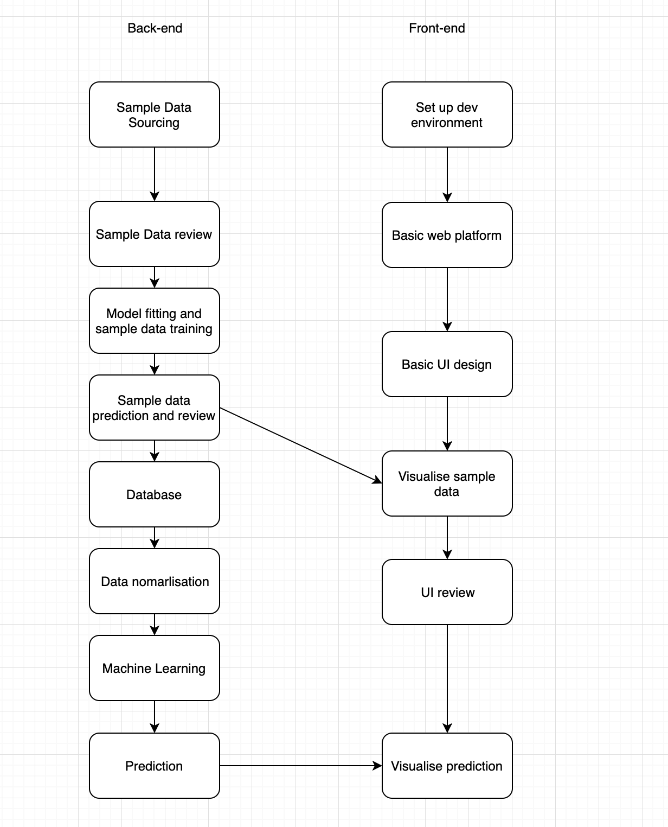

In the current stage, we have designed a methodology for data collection. The data collected are still under exploration level “Search for possible data source”.

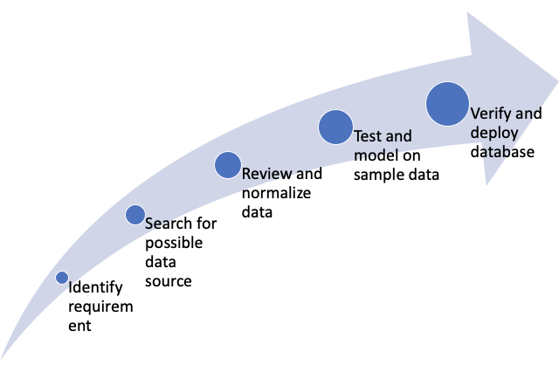

## Data sourcing

In this project, we aim to source all our data from public data source. There are several benefits to our client. Firstly, it saves the cost to develop. Secondly, public data allow the user to trace the data source to make the prediction more convincing. Therefore, most of our data are acquired from Australian Government Sites. For example, Geoscience Australia, the Australian Government Database provides many data including climate, solar, and energy grid. On the other hand, we require a map which allows the user to browse through, therefore, a map API would be a great choice to reduce the cost. Develop a functional map is redundant and costly. Many map API exists and allow for easy implementation and grant efficiency.

## Our data sources

## Data normalization

In this stage, we realized that many data contained irrelevant information. An example would be climate data from the weather station. Name of the weather station would be redundant as it can be inefficient to machine learning. Another example is data can contain null value sometimes, we need to eliminate those data.

## Data Storage

## Development kit and relations

## Computation Design

Our algorithm is designed to do a basic calculation of cost and profit and use machine learning to find out the suitable renewable technologies that can be used in an area. We have category our development into four phases

### Phase1

Setting up basic framework with basic user interface. Integrate layer data into the webpage and visualize them. This including solar, wind, and water data. However, no calculations and computation are made in this stage.

### Phase2

Besides layer data, map server data such as energy grid is implemented into the websites. The website should be able to calculate the area of user selected, and computed the potential outcome of different locations.

### Phase3

Calculate the potential cost by identifying other renewable technologies developer. Thus, compute the return of investment. Use complex algorithms or machine learning strategy to compute the best combination of different renewable technologies in user-selected area

# Project timeline

## Schedule & Milestones

Refer to **APPENDIX A**

# Project management

## Change management

## Task Tracking

For effective take allocation and management, task tracking software is used within the project to monitor the task completion status as well as promoting the productivity of the team according to the importance of each task.

Trello is selected as the team’s task tracking software since it enables to keep all the tasks in one place based on different aspects, such as frontend, backend, and documentation. Trello allows task prioritization to let everyone understand which task is more important, it also a good software for collocation among the project team for sharing ideas and feedback.

After all the team members are invited to the same project on Trello, tasks can be created and allocated to each individual, each task has the description, priority, due date and the members in charge of it. Every team member is able to add comments under each task, hence, an exchange can be made easily and efficiently. The project manager can monitor the progress of each task and planning ahead for the next task or dealing with the delayed task on Trello. Therefore, Trello plays an important role to avoid losing work, meanwhile, track tasks to stay on schedule and every team member is on the right track.

## Decision making process

The change the executive's procedure in frameworks building is the way requesting, arranging, actualizing, and assessing of changes to a framework. A formal decision-making system will be implemented to help the project team effectively choose among two or more alternative for a certain goal or task, as well as recording every decision made for future reference and evaluation.

For the decision-making process, four steps will be followed and recorded. Firstly, recognize and define the nature of a decision situation which states the problem. Followed by identifying alternatives and states the final best choice with reasons. Last but not least, based on the decision made, states the potential impacts or outcomes.

For each of the decision, the four steps of decision-making will be captured within a table and all the decisions will be organized into one single document at the end. Besides the four key steps, time, people involved, status, team recommendations together with final management approval will also be included. Our decision-making log form can be found in **APPENDIX B**.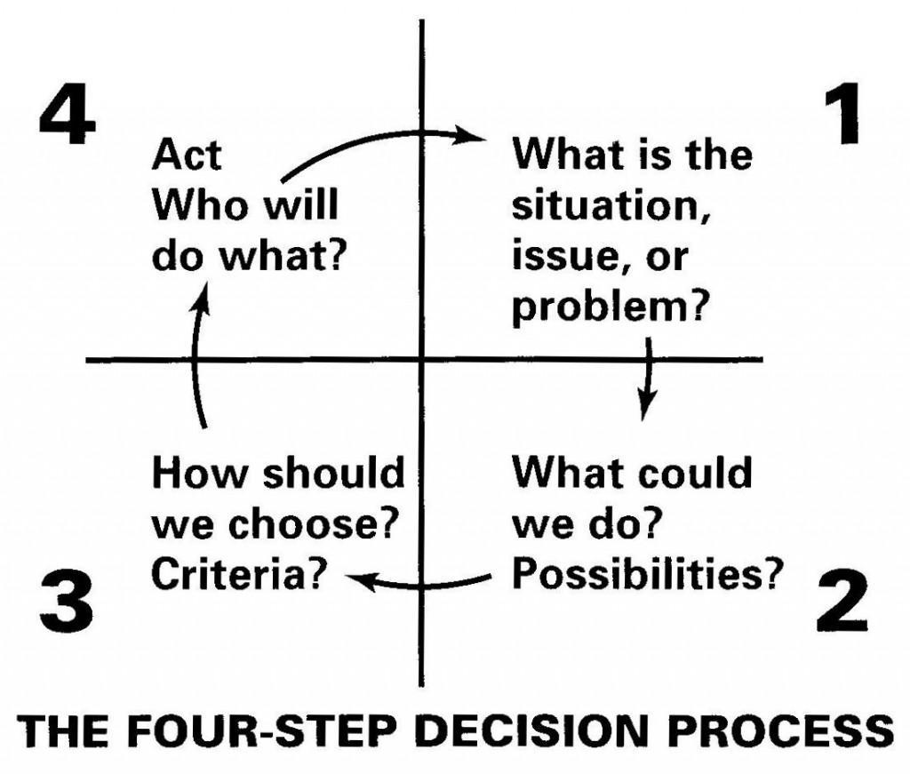

(CompanyCulture.com, 2019)

# Inspection, test, integration, and acceptance

# Reference

CompanyCulture.com (2019). *321 — Make Better Decisions*. [image] Available at: http://companyculture.com/321-make-better-decisions/ [Accessed 25 Mar. 2019].

# Appendix A- Project schedule

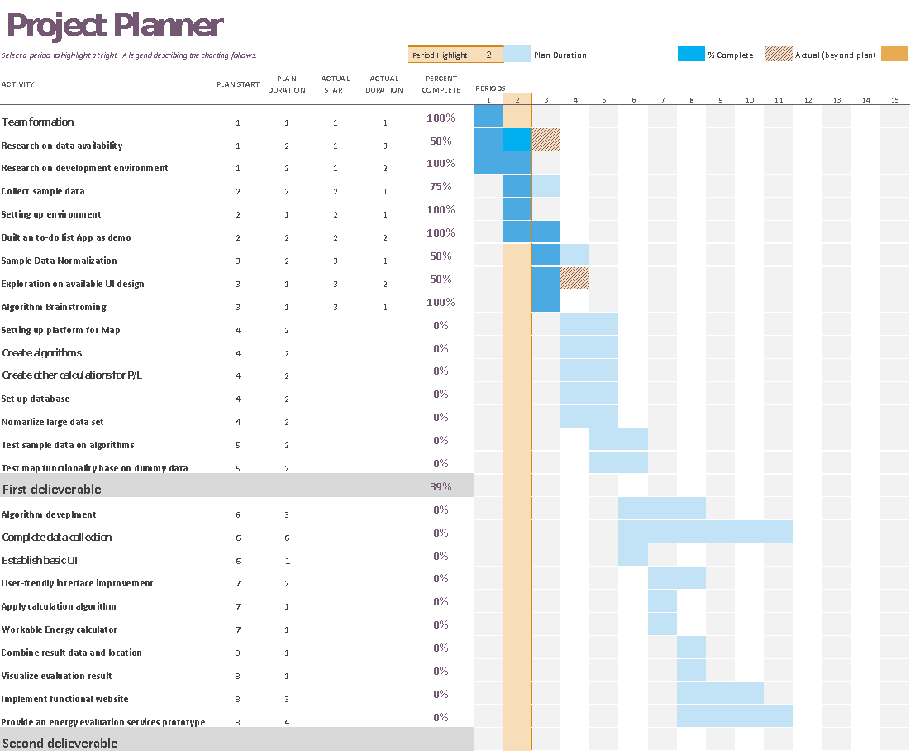

# Appendix B- Decision-making Log Form

Decision-making Log Form

|  |  |
| --- | --- |
| **General Information** | |
| Project | Decision Number |
| Energy Storage Rights |  |
| Date | Priority |
|  |  |

|  |  |  |
| --- | --- | --- |
| **Decision** | | |
| **Description – Describe the nature of the decision** | | |
|  | | |
| **Alternatives – Briefly describe the choices** | | |
| Name | Description | Justification – why the alternatives should be used |
|  |  |  |
|  |  |  |
|  |  |  |
| Supporting documentation – Screen layouts, designs, reports, etc. (provide the link) | | |
|  | | |

|  |  |  |  |
| --- | --- | --- | --- |
| **Team Recommendations** | | | |
| Review Date | Team Members | Notes | Preference |
|  |  |  |  |
|  |  |  |  |
|  |  |  |  |
| **Final Decision** | | | |
|  | | | |
| **Impact/outcome of the decision** | | | |
|  | | | |

|  |  |  |  |
| --- | --- | --- | --- |
| **Management Approval** | | | |
| Final Approval Date | Name | Title | Recommendation |
|  |  | Projector Manager | ☐ Approve  ☐ Reject |